

Faculty of Engineering (Degree)
Semester – 1
Subject Name – Programming for Problem Solving
Subject Code – BE200104
Faculty Name – Ashwini Walake
Unit - 6: Strings and String Handling

String
A string is an array of characters terminated by a special character '\0' (null character). This null character marks the end of the string and is essential for proper string manipulation.
Unlike many modern languages, C does not have a built-in string data type. Instead, strings are implemented as arrays of char.
Example
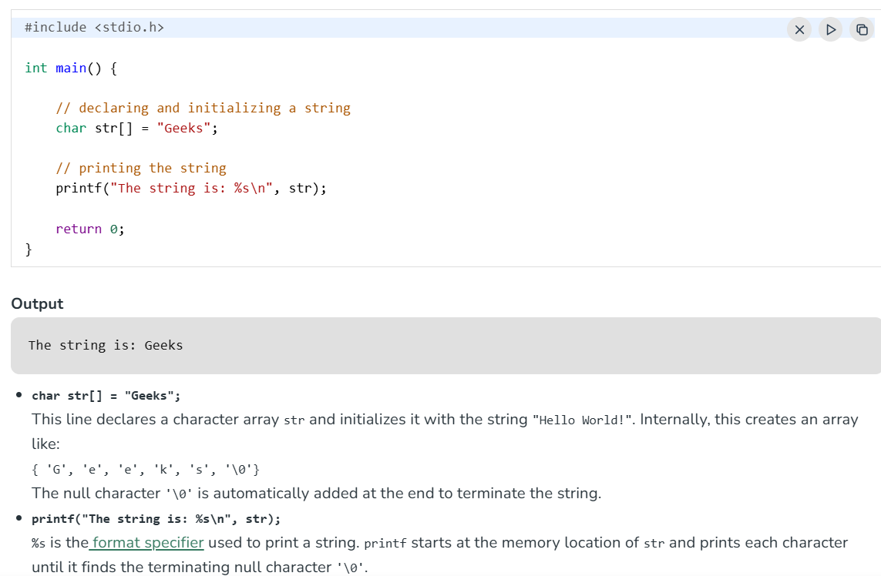
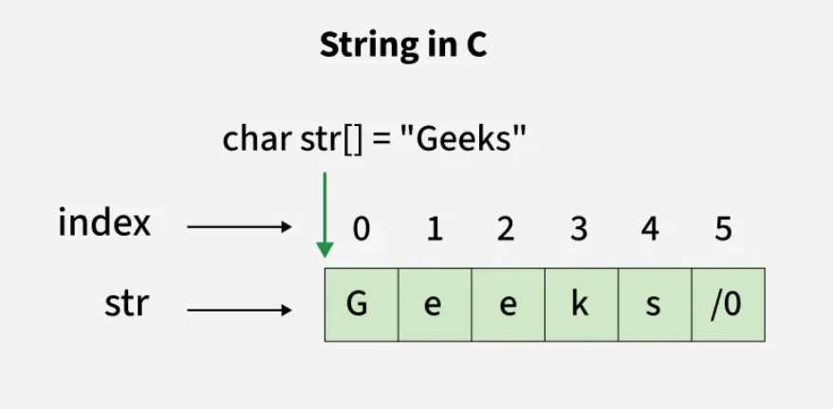

Declaration
Declaring a string is as simple as declaring a one-dimensional array of character type. Below is the syntax for declaring a string.
char string_name[size];
In the above syntax string_name is any name given to the string variable and size is used to define the length of the string, i.e. the number of characters strings will store.
Like array, we can skip the size in the above statement:
char array_name[];
Initialization
We can initialize a string either by specifying the list of characters or string literal.
// Using character list
char str[] = {'G', 'e', 'e', 'k', 's', '\0'};

// Using string literal
char str[] = "Geeks";
Note: When a Sequence of characters enclosed in the double quotation marks is encountered by the compiler, a null character '\0' is appended at the end of the string by default.
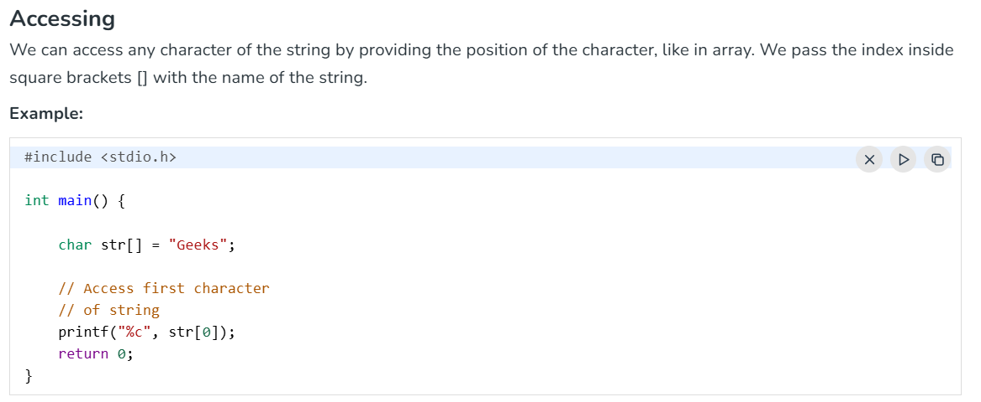
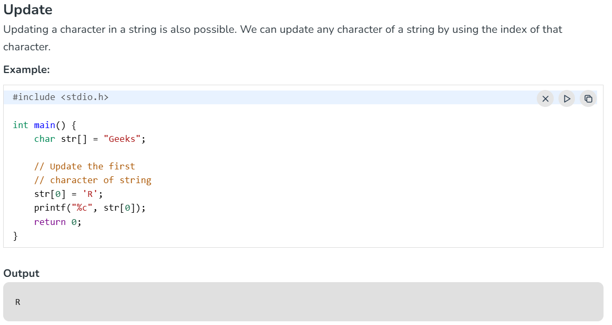
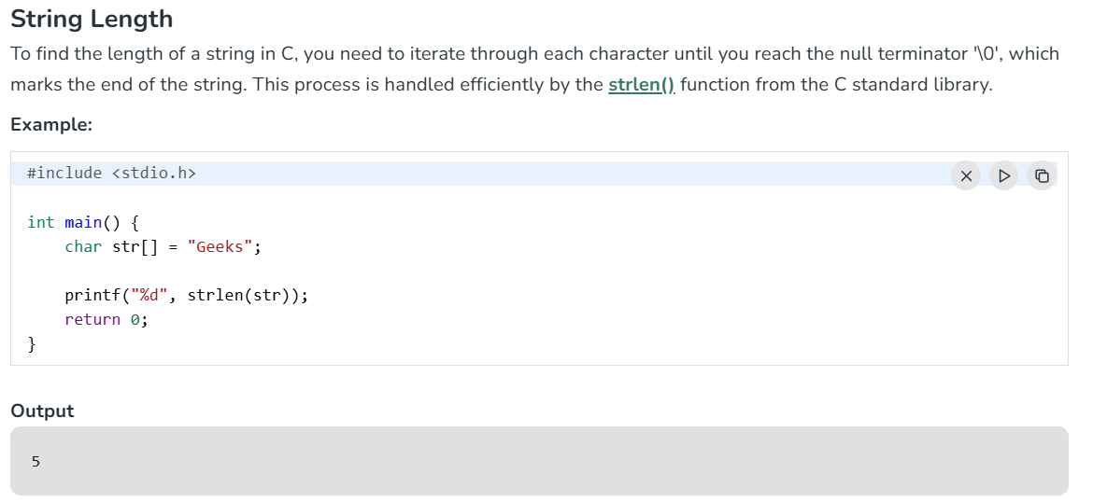

String Input
In C, reading a string from the user can be done using different functions, and depending on the use case, one method might be chosen over another. Below, the common methods of reading strings in C will be discussed, including how to handle whitespace, and concepts will be clarified to better understand how string input works.
Using scanf()
The simplest way to read a string in C is by using the scanf() function.
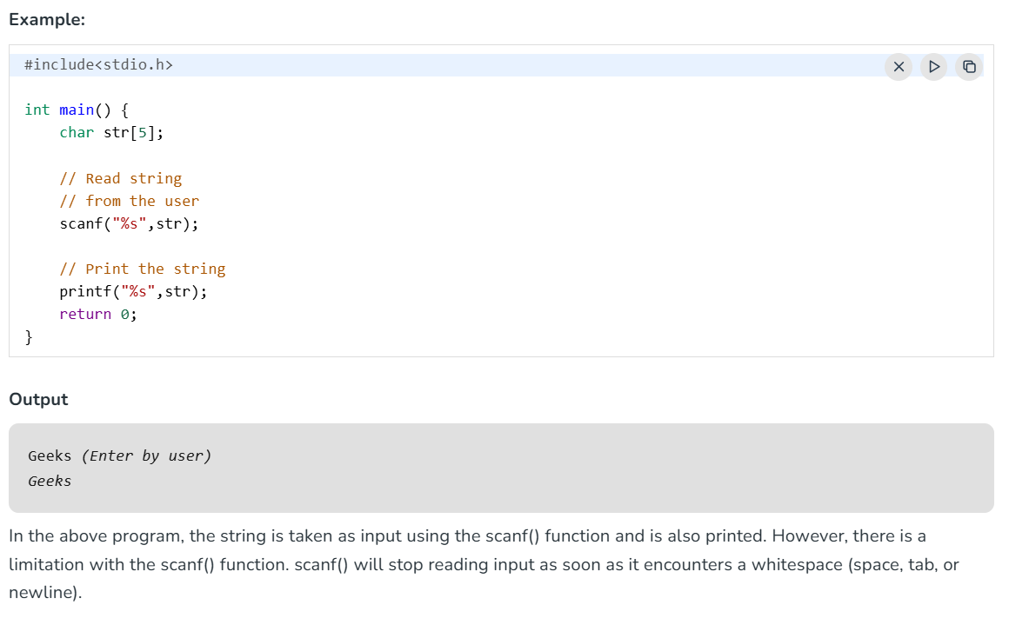
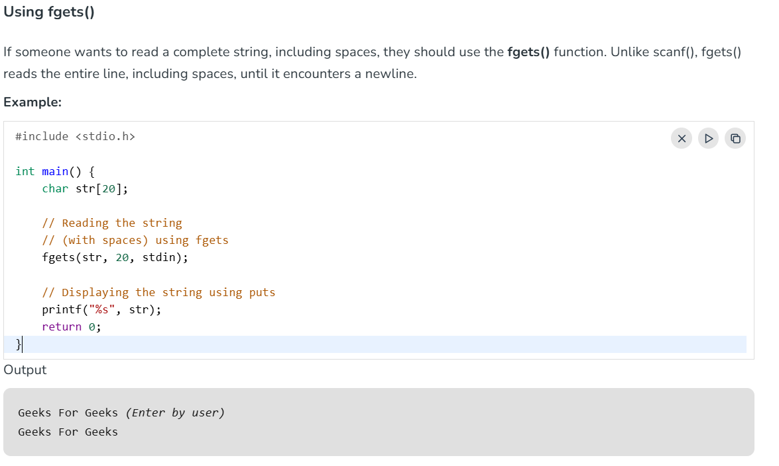
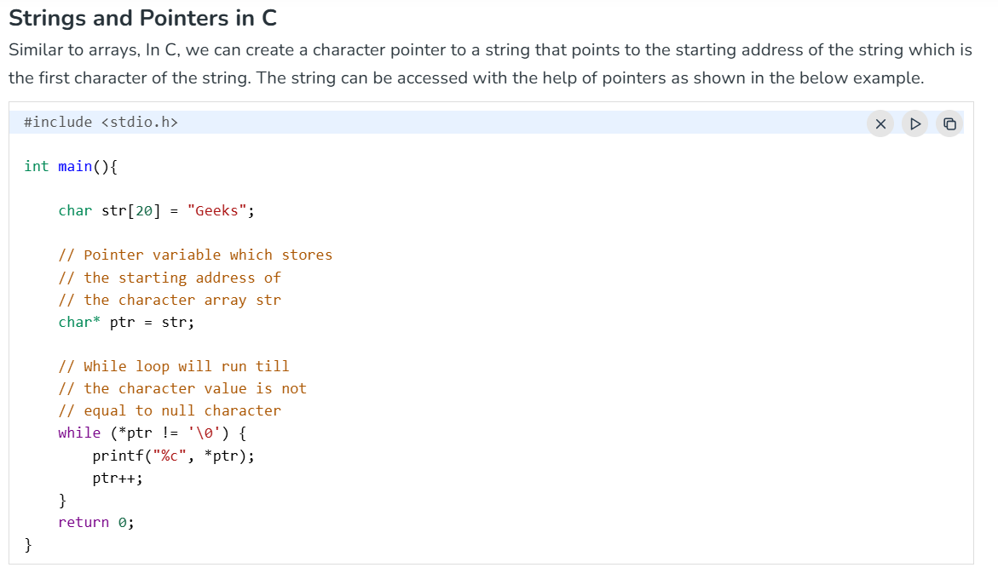
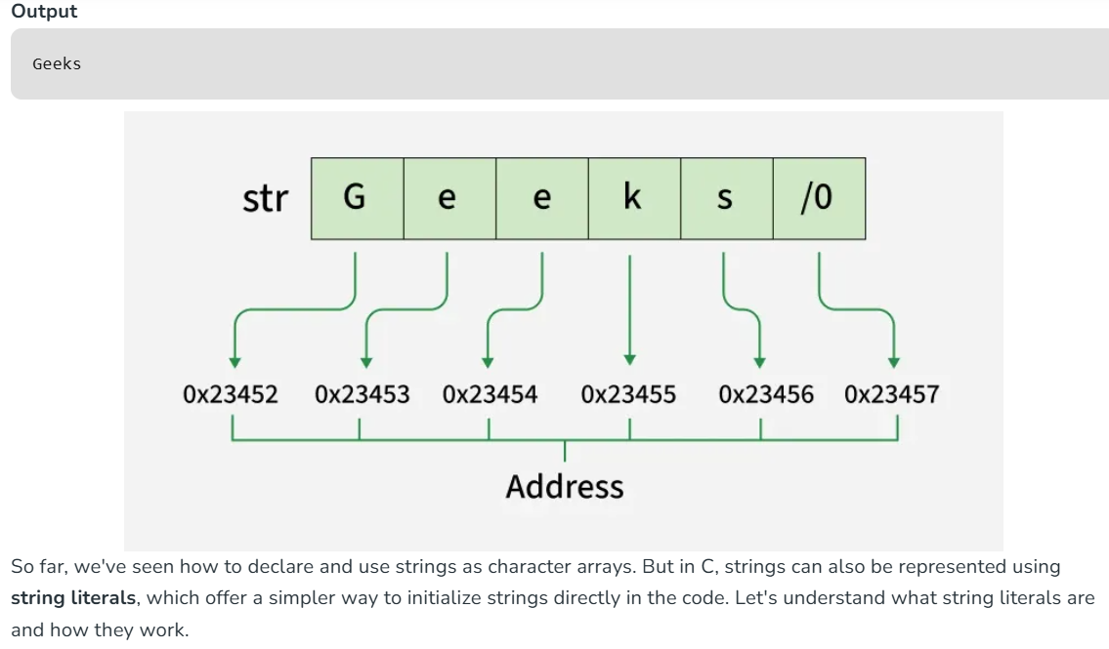
Array of Strings in C
In C, an array of strings is a 2D array where each row contains a sequence of characters terminated by a '\0' NULL character (strings). It is used to store multiple strings in a single array.
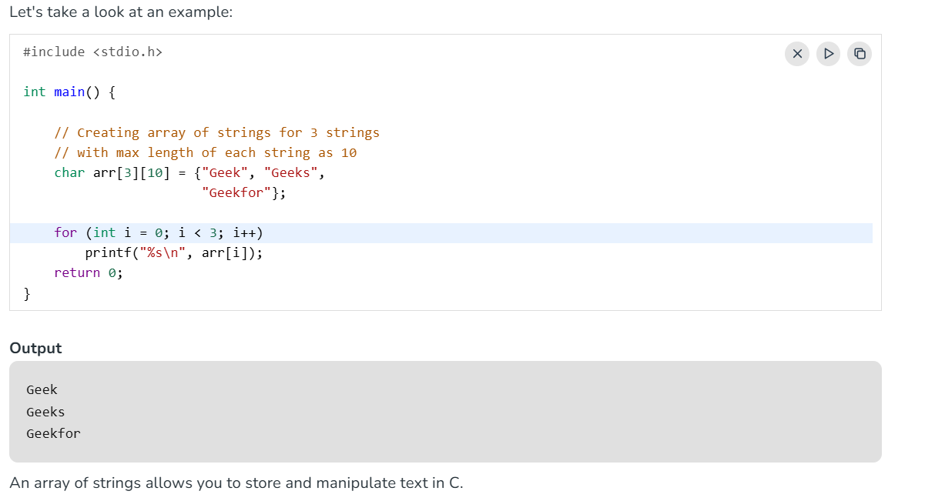
Syntax of Array of Strings
char arr_name[r][m] = {s1, s2, ...., sn};
Here,
- arr_name: Name of the variable.
- r: Maximum number of strings to be stored in the array
- m: Maximum number of character values that can be stored in each string.
- s1, s2, ...., sn: Strings to be stored.
Invalid Operations in Arrays of Strings
We can't directly change or assign the values to an array of strings in C.
Example:
char arr[3][10] = {"Geek", "Geeks", "Geekfor"};
arr[0] = "GFG";
// This will give an Error that says assignment to expression with an array type.
To change values we can use strcpy() function in C:
strcpy(arr[0],"GFG");
// This will copy the value to the arr[0].
How Array of Strings are Represented in Memory?
Consider the array of string:
char arr[3][10] = {"Geek", "Geeks", "Geekfor"};
It will be stored in the format shown below:
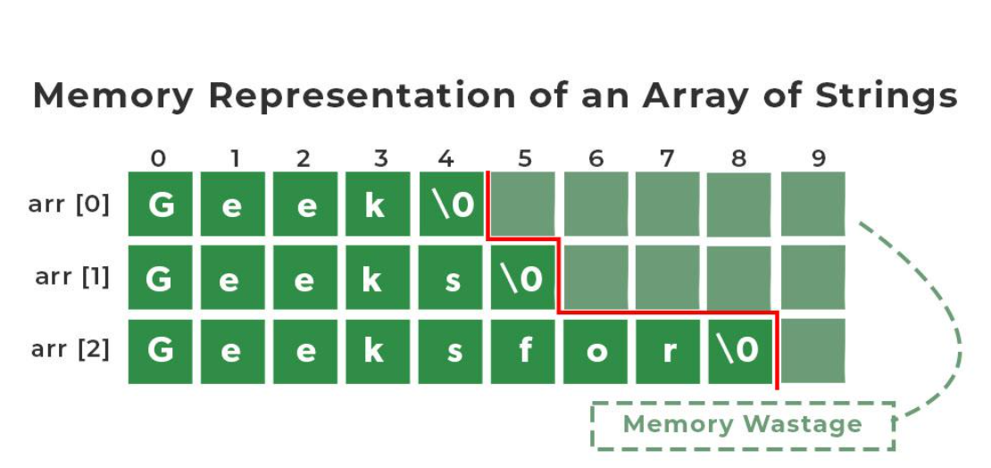
We have 3 rows and 10 columns specified in our array of string which means that each string can be as long as 1o characters. But as we can see, there are many strings that takes less space than 10 but still allocated the same space due to the property of 2D array. It leads to so much wastage of space. But we can avoid this wastage in our program by using array of pointers to strings.
C String Functions
C language provides various built-in functions that can be used for various operations and manipulations on strings. These string functions make it easier to perform tasks such as string copy, concatenation, comparison, length, etc. The <string.h> header file contains these string functions.
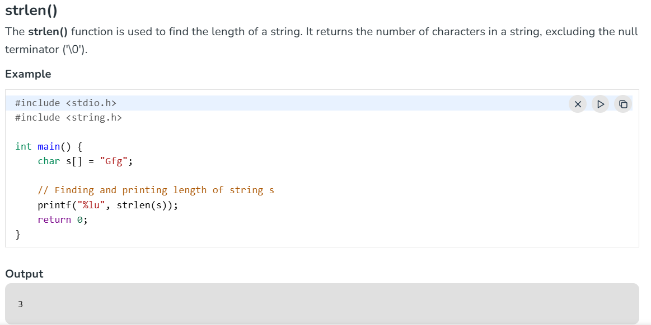
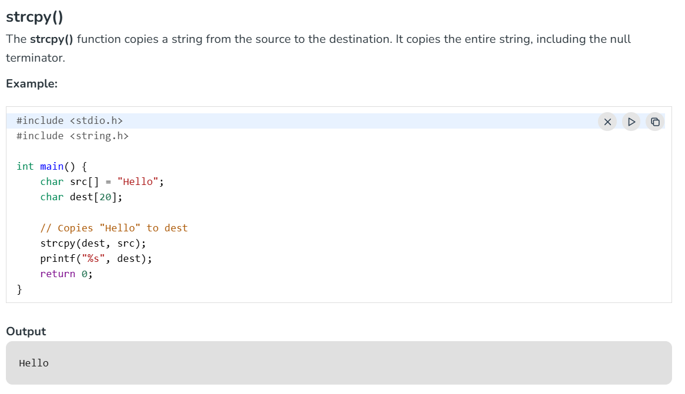

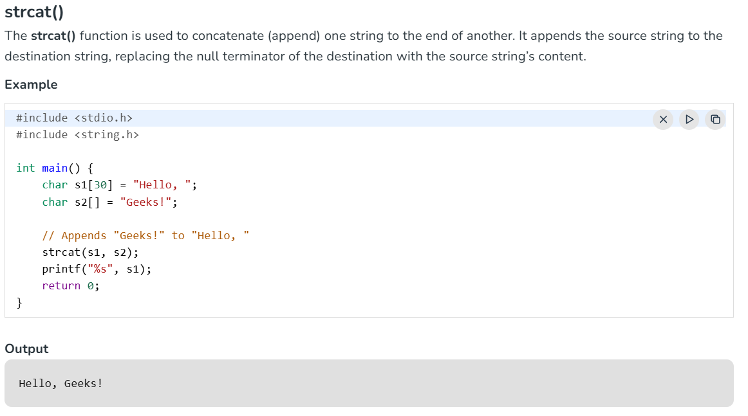
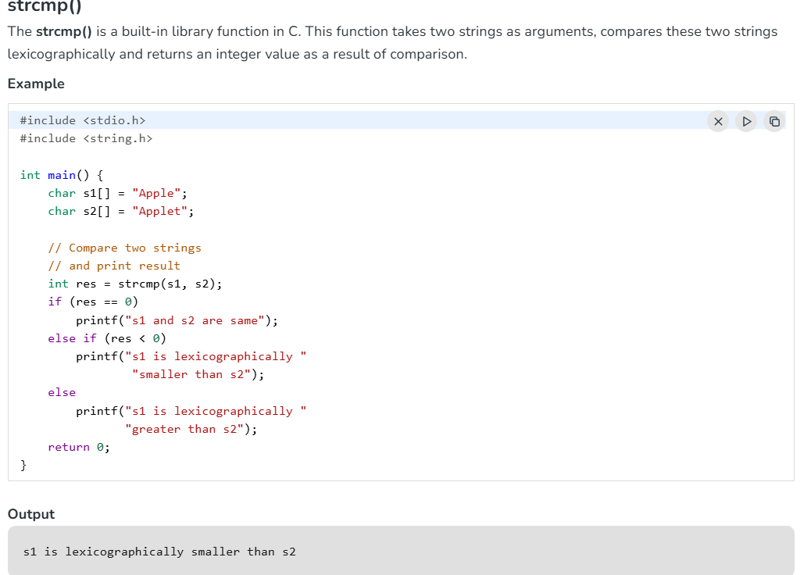

Applications of String:
- Plagiarism Checker: Strings can be used to find Plagiarism in codes, and contents in a very little amount of time using string matching algorithms. Using this the computer could easily tell us the percentage of code, and text written by any two users matches by how much percent.
- Encoding/Decoding(Cipher Text Generation): Strings can be used for encoding and decoding for the safe transfer of data from sender to receiver to make sure no one in the way of transmission gets to read your data as they could perform both active and passive attacks. The text you transfer as a message gets ciphered at the sender's end and decoded at the receiver's end.
- Information Retrieval: String applications help us to retrieve information from unknown data sources( large datasets used as input) along with the help of string matching/retrieval module helps us to retrieve important information.
- Improved Filters For The Approximate Suffix-Prefix Overlap Problem: Strings and its algorithms applications help us to provide improved Filters for the Approximate Suffix-Prefix Overlap Problem. The approximate suffix-prefix overlap problem is to find all pairs of strings from a given set such that a prefix of one string is similar to a suffix of the other.
- Network communication: Strings are used to encode and decode data sent over networks, such as HTTP requests and responses.
- File handling: Strings are used to manipulate file paths and names, and to read and write files.
- Data analysis: Strings can be used to extract meaningful insights from large amounts of text data, such as natural language processing and sentiment analysis.

